ASSIGNMENT 21

PRANEESH SHARMA

B22

21052264

Q1. Write a program to display various bitwise operations.

Code:

//Program displaying various bitwise operations

#include <stdio.h>

int main()

{

    unsigned int a=60;

    unsigned int b=13;

int c=0;

    c=a&b;

printf("\nLine 1 - Value of C is: %d", c);

    c=a|b;

printf("\nLine 2 - Value of C is: %d", c);

    c=a^b;

printf("\nLine 3 - Value of C is: %d", c);

    c=~a;

printf("\nLine 4 - Value of C is: %d", c);

    c=a<<2;

printf("\nLine 5 - Value of C is: %d", c);

    c=a>>2;

    printf("\nLine 6 - Value of C is: %d", c);

}

Output:

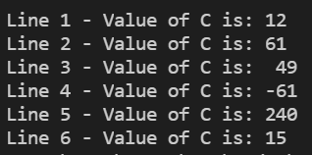

Q2. Write a program to display the working of enum.

Code:

//this program displays the working of enum

#include <stdio.h>

enum week{Sunday,Monday,Tuesday,Wednesday,Thrusday,Friday,Saturday};

int main()

{

    enum week today;

    today=Wednesday;

    printf("%dth day", today+1);

    return 0;

}

Output:



Q. Write a program to display .

Code: